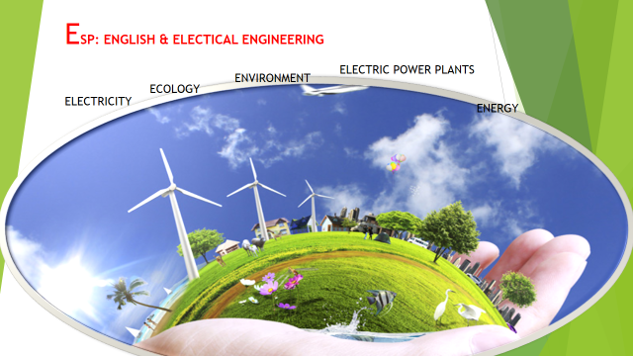
Electricity is produced at an electric power plant. Some fuel source, such as coal, oil, natural gas, or nuclear energy produces heat. The heat is used to boil water to create steam. The steam under high pressure is used to spin a turbine. The spinning turbine interacts with a system of magnets to produce electricity. The electricity is transmitted as moving electrons through a series of wires to homes and business.
